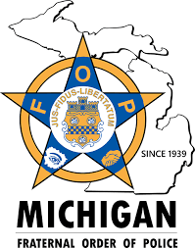
Lodge 106 Scholarship

Description: To promote and encourage the endeavors of any person who is interested in pursuing a career in Law Enforcement.

Qualifying Criteria: A scholarship awarded to a graduating Senior of a St. Joseph County High School or graduate of a St. Joseph County High School that has been accepted into a Police or Corrections Academy. Scholarship winners must show proof of acceptance into a college or university with an accredited Law Enforcement Program or an accredited Police or Corrections Academy. Failure to provide proof of acceptance will cause the award to be forfeited and no money will be distributed.

Application Process: Applicants will complete the application/essay and submit it to the school representative. A Fraternal Order of Police Lodge 106 committee will review all applications and determine the winner of the scholarship.

Deadline: March 22nd

